_{Hambledon Primary School}
Summer Term 2 Dolphins Class Mrs Sansom / Mrs Blower
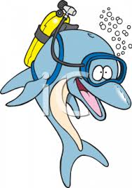
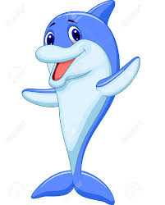
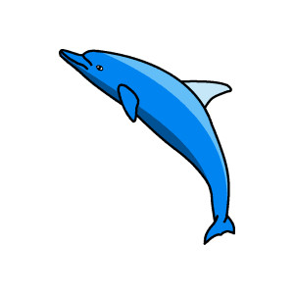


_{Learning Log}
In Literacy this week the children write and edited a recount of their trip to the Vitacress Herb Farm. They concentrated on using questions and exclamations to make their writing interesting for their audience and subordinate clauses (using when, if, because) to extend their sentences. This tied in with their SPAG work on extended sentences. Please see the Newsletter to read a few examples of their recounts. They then planned and wrote an explanation text to explain how the herbs are grown and prepared at the farm ready to be sold in the shop. They again thought about how to include questions and exclamatory sentences to hook in their readers. They also concentrated on writing in clear steps so someone could follow the process.
We went on to read Katie Morag delivers the mail. We used this book to write a new ending for the story and write captions for the characters on a map of the island.

In Numeracy we have been solving lots of Katie Morag problems! We started the week by figuring out how many ways Katie Morag could pay for the stamps she needed on her parcel and then we looked at how much change customers in th post office would get. We worked this out by estimating first and then counting back on a number line. We used our fraction walls to help us work out how many parcels she had to deliver is she was delivering 1/3 or 34 fo the mail. We have also been telling time in 15 and 5 minutes intervals. We finally developed our understandiing of 2D shapes. We wrote descriptions that included the name, number of sides, number of vertices and if it was symmetrical.

_{Week beginning: 06.06.16}
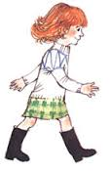

In Music the children were following a rhythm using the A and G notes on their recorders. They were also writing notes of a scale of 2 lines.

In Geography we began by talking about what an island was and then thought of some examples of islands. We read some of the Katie Morag stories to listen out for clues as to what might be on the Isle of Struay before drawing a map of the island.
In RE the children recapped the story of 5 loaves and 2 fish and then discussed the significance of the story.

In Science we explored and compared the differences between things that are living, dead, and things that have never been alive by thinking about life processes. We sorted pictures of items in to theses categories and then wrote about them. We also had fun playing the ‘yes/no’ game !

In Art the children began to think about landscapes in art. This week we looked at Claude Monet’s paintings of his gardens. The children then had a go at painting their own garden using their fingers to dab on the paint.
On Monday the children listened to some traditional Scottish music before watching a video of children dancing the Circassian Circle. They came up with instructions to follow so we could dance it as a class. In Multi-skills we began thinking about athletic activities. We focused on running and sprinting.

