_{Hambledon Primary School}
Summer Term 2 Dolphins Class Mrs Sansom / Mrs Blower
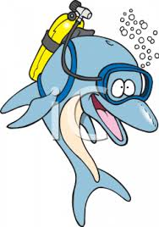
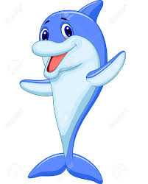
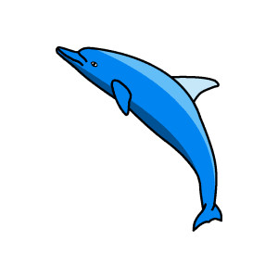
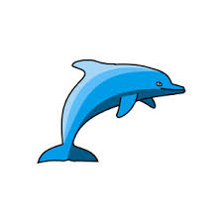

_{Learning Log}
In Numeracy we have been subtracting. We have learned how to use an unstructured number line (one without numbers on already) to record our jumps and have been jumping back in multiples of 10 before taking away the units in one jump instead of in 1s. To do this we have had to be quick with our number bonds of numbers 1-10. We then looked at different ways to subtract efficiently such as rounding and adjusting. For example, to subtract 19 we could take away 20 and then add 1 back on. We then looked at how to use number bonds to help us cross the tens barrier. For example if we were doing 54 – 7, we could split the 7 into a 4 and a 3 to jump back to 50 and then 47.

In Literacy this week the children have been researching facts about the Isle of Struay and the Isle of Coll. They then used these facts to write their own fact books. The children focused particularly on writing headings and subheadings, detailed sentences and captions for illustrations. At the end of the week the children wrote a contents page and a blurb and designed a front cover. The children would love the opportunity to share their work with you.

_{Week beginning: 13.06.16}
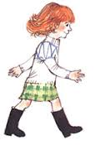

In Music the children listened to some Scottish songs and learned the song that Katie Morag like to sing – ‘Ye cannae throw yer granny off the bus!’. They were using the A, G and C notes to play a pattern on the recorder and composed their own pieces.

In Geography we learnt about the difference between human and physical features. We discussed what features we would find on the Isle of Struay and sorted them into the two headings.

In Multi-skills we were learning how to jump. We practised jumping from two feet to two feet and one foot to two feet while remembering to bend our knees when landing. We then jumped even farther by including a run up and swinging our arms. In Dance we worked as a class to perform a Scottish dance and then broke off in to groups to think of movements we could add to make it even better!
In Art the children have been learning about the landscapes painted by Van Gough. They watched a video showing how he applied the paint thickly to create movement. The children then had a go at painting their own landscape in the style of Van Gough.
In Science we have been learning about habitats and microhabitats. We visited parts of the school grounds to look at the plants and animals that lived there. The children grew pictures and labelled them. They then sorted pictures of animals and plants in to different habitats.

