_{Hambledon Primary School}
Summer Term 2 Dolphins Class Mrs Sansom / Mrs Blower
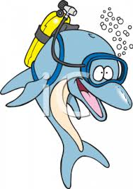




_{Learning Log}
In Literacy this week the children started the week by writing postcards and letters from the Isle of Struay. We looked at the differences and similarities to these two types of writing and also discussed the purpose of them. They learned that for a letter, we write in paragraphs and can include more detailed information about an event while a postcard is a shorter summary of events.
We then went on to design and create posters to encourage visitors to come to the Isle of Struay. We learnt that an effective poster has a bold title, bright colours, pictures with captions and interesting information for a reader.
In Numeracy we have been learning how to interpret different types of graphs such as a bar chart and a pictogram. We’ve discussed the importance of the features, such as a key and a title, to help us find out the information the graph is telling us. We answered questions such as ‘How many more…’ and ‘How many altogether…’ along with ‘Which has the most/least..’ The children also learned how to read scales that went up in more than 1s and what to do if there was half a picture or the bar came half way between two numbers on the scale. They then collected their own data to answer a question and learned how to present this in a bar chart and a pictogram.
_{Week beginning: 27.06.16}
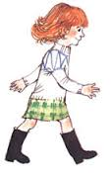

In Music the children built on their pattern using the A,G,C notes and learned how to play the D note before incorporating it into their pattern. I was very impressed with their reading of music when they followed the pattern to ‘Maeri’s Wedding’!

In DT the children used their knowledge of physical features of islands to start constructing their own islands. They worked together as a group to build up the shape of their islands using newspaper.

In Geography we reviewed the differences between human and physical features and discussed what physical features we’d expect to see on an island.

In Art we have looked at landscapes painted by the artist Jean Metzinger. We found out that he was a neo-impressionist and painted using bright colours in patches almost like a mosaic. We had a go at creating our own landscapes using squared paper and colouring pencils.
In Science we have begun to learn about different habitats that can be found around the world such as the ocean, the jungle, the desert and the arctic. We had to work in teams to research a habitat and then present the information to our class. We also thought about good questions we could ask other groups about their habitat.

In Dance we worked in our groups to compose our own Scottish dances before presenting them to the rest of the class.
In Multi-skills

