_{Hambledon Primary School}
Summer Term 1 Dolphins Class Mrs Sansom / Mrs Blower
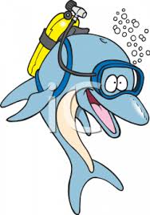
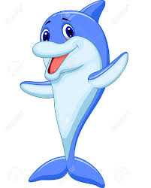
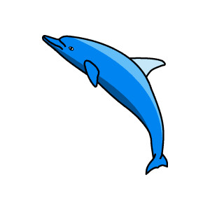


_{Learning Log}
In Literacy this week the children continued their work with Handa’s Surprise. The children used their own story maps to finish writing their stories. The children worked hard to add in noun phrases to describe the animals in the story.
They then looked at the sentence pattern used in the story, which can be viewed at https://www.youtube.com/watch?v=y1Vmf4Cwvls, before using expanded noun phrases and ‘or’ to write sentences in a similar style.
They also read the story ‘The Day the Crayons Quit’ by Drew Daywalt and wrote a letter to Duncan as one of the crayons. They concentrated on using questions, commands and exclamations while also getting across the feeling of the crayons.
In Numeracy the children began a unit on Measures. They started by looking at the coins that we use and how to combine them to make different totals. They thought about how they could make totals with the fewest number of coins and which totals could and couldn’t be made using only silver coins.
The children then applied this knowledge to play the following money games.
- www.ictgames.com/payForIt/index.html
- www.topmarks.co.uk/Flash.aspx?f=Buy2itemsv4.
- www.bgfl.org/bgfl/custom/resources_ftp/client_ftp/ks2/maths/shop_counter/index.htm
They used real coins and money numberlines to help them solves these problems.
_{Week beginning: 02.5.16}


In Music the children enjoyed a Maypole Dancing workshop to celebrate the start of May. They had an assembly with Mrs Harmer where they learnt a May Day song and then later in the day they took part in workshop where they learnt a dance to show to the parents at the end of the day.

In SPAG the children have been continuing their learning about contractions. They have been using these words in sentences and looking for opportunities where they could have used them in their writing. We have discussed the different times you might use them and when you would use a more formal approach.
Reminder – Please return your consent form for our trip to Vitacress Herb Nursery.
In Science we looked at the life cycle of a sunflower. We also talked about the life processes of plants and discussed how some are the same as humans. We went on to look at our bluebell bulbs and sunflower seeds to see if they had started growing. We drew what they looked like and measured the height if there were any shoots.

In Art the children used what they found out last week to make a fruit portrait using ‘TuxPaint’ by selecting different fruits, altering the size and position and applying different effects.
In Multi-skills we worked in pairs to pass a ball back and forth using a small bat. We did this along the ground and in the air. It was much trickier that it looked!

