_{Hambledon Primary School}
Summer Term 1 Dolphins Class Mrs Sansom / Mrs Blower
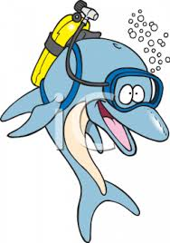
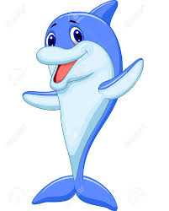
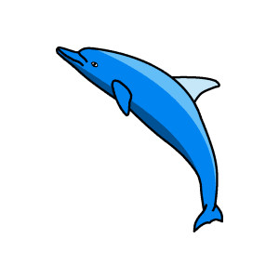
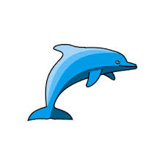

_{Learning Log}
In Literacy the children started the half term by looking at a poem called ’The Recipe for a Story’ by Ella Burfoot. They learned about prepositions and used these words in sentences to describe a kitchen scene.
We then moved on to learning about rhyming couplets. We listened for rhymes in the poem and then had a go at writing our own couplets. We finished the week by writing our own rhyming poems called ‘Recipe for a Friend’.
In Numeracy the children started a unit on Shape They began by naming and describing 2D shapes by their properties and then began to compare them. They learned about right angles and lines of symmetry in shapes. Once they could describe 2D shapes by their properties, they used Venn diagrams to sort them. The children then repeated these activities with 3D shapes. We have finished off the week by learning about positions and turns. We had fun in the hall moving our bodies and then applied it to moving Bee Bot robots around a map.

_{Week beginning: 11.4.16}
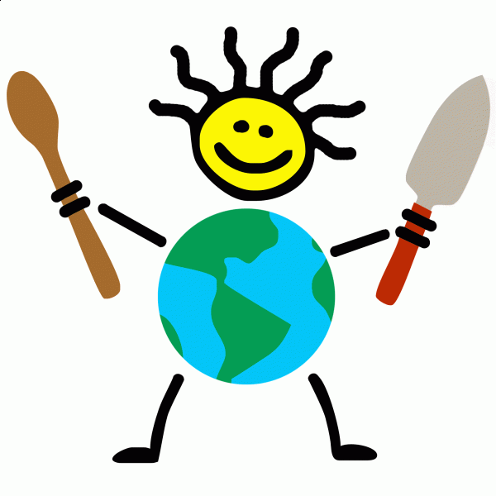

In Music the children learnt how to hold and make a sound with a descant recorder. They also learnt how to play the note ‘C’.
In SPAG the children have been revising using the past tense. They have looked closely at the spelling of verbs in the past tense and how the spelling changes when adding eed. They also looked at irregular verbs.
We have also been changing adjectives in to nouns by adding the ‘ness’ suffix. We are now confident when applying the rule ‘drop the y and an i’.
In Science we have begun to learn about plants.
We have thought about how we know a plant is alive or dead and the similarities they have with animals. We have done some observational drawings of plants and labelled the different parts. Finally we named some common plants and discussed their uses.
In Geography the children began their topic at looking at food from around the world. They learnt the names of the 7 continents and major oceans before using an atlas to locate these. They then identified them on a map of the world. They chose a country from a continent to research and again used an atlas to locate and colour their country in on a map of the continent.

In Multi-skills the children worked with partners to throw and catch different balls. We then moved on to playing small games with tennis rackets.
In Art the children looked at artwork by the artist Giuseppe Arcimboldi and discussed what a portrait is and how he made his portraits. They identified the fruits used in his portraits and discussed why he had chosen them.

