_{Hambledon Primary School}
Summer Term 1 Dolphins Class Mrs Sansom / Mrs Blower
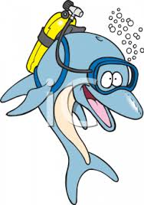
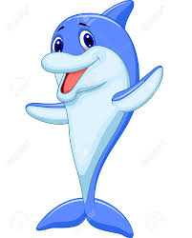
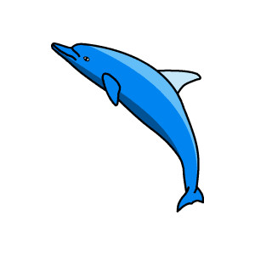


_{Learning Log}
In Literacy this week the children have been learning about Explanation Texts. They watched a short video of how wheat is turned into bread and used this to create a flow chart to show the process. They used their flowchart to write their text, concentrating on using paragraphs, writing an introduction, using time connectives and including questions. They then went on to reading the story of The Little Red Hen. The children acted out parts of the story that described how bread was made and used photographs of themselves to sequence the process. The children also wrote speech for the characters in giant speech bubbles.

In Numeracy the children started a unit on Fractions. They started the week learning about the numerator and denominator and what these numbers mean. They used diagrams and fraction walls to find ½, 1/3 and ¼ of objects and shapes. They discussed the difference between groups of 4 and 4 groups to help them find quarters and looked at the relative sizes of ½, 1/3 and ¼. Finally they played a game where they had to colour fractions of a shapes.

_{Week beginning: 18.4.16}
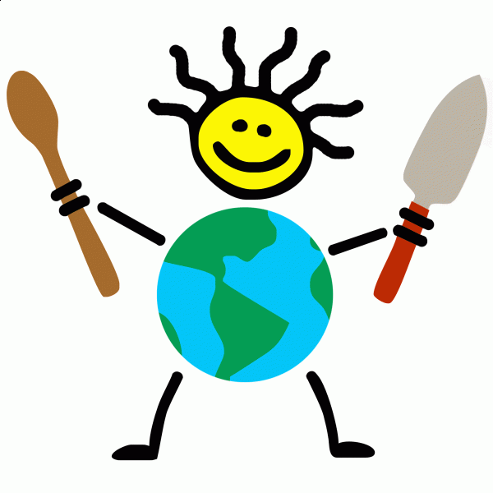

Honeycomb Reward
The children have chosen to bring their teddies in for a day as their Honeycomb Treat. This will be on Tuesday April 26th. We look forward to seeing all of their teddies!
In SPAG the children have been learning about the 4 different sentence types: commands, exclamations, statements and questions. They have looked at the different punctuation at the ends of these sentences and practised recognising and writing the four types.

In Science we have been learning about germination. The children watched a short video and discussed what seed or bulb would need to germinate and what it would need to continue growing healthily. They then planted shallot bulbs and runner bean seeds under different conditions to find out which is best.

In Geography the children researched facts about the countries that they chose last week. Included in these facts had to be a fact about the food eaten or grown there. They also conducted a favourite fruit survey of the class and recorded this information in a tally chart before learning how to show the same information in a bar chart.
In Art the children continued to look at artwork by the artist Giuseppe Arcimboldi. This week they created portraits in his style by using oil pastels. Then they compared the difference between pencil and oil pastel.

In Multi-skills we played golf. The children had to put the ball through cones to hit a flag whilst trying to stay out of the rough. It was great fun!
In Music the children revised the ‘rest position’ and the A and C notes. They echoed patterns by clapping and then using their recorders.

