_{Hambledon Primary School}
Summer Term 1 Dolphins Class Mrs Sansom / Mrs Blower
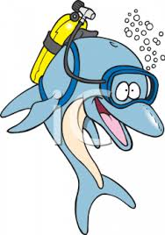

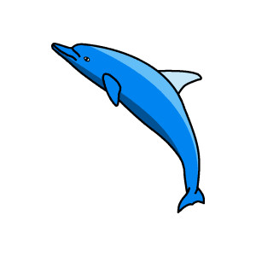
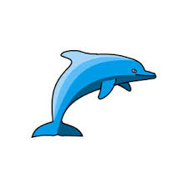

_{Learning Log}
In Literacy this week the children listened to John Burningham’s ‘Would you rather’ story before writing their own stories. They followed his sentence pattern and used ‘or’ to form a question. They had to concentrate on using a ? at the end of their writing and a comma between their choices if they offered more than two choices. They then looked at including an exclamatory sentence after. They edited and improved their writing before creating their own books. The children have also been writing sentences with dialogue. They had to show they understood how to use speech marks and remember to write who was talking. They used characters from the Handa’s Hen story to help them.

In Numeracy the children continued to look at finding change after choosing some fruit to buy. They worked on 2 step problems where they had to buy more than one piece of fruit and find the total before finding out how much change they would get.They also used their reasoning skills to say which fruit they could buy if they had £1 to spend.
They then went on to learning about reading scales. The children had to compare weight and record the numbers they could see. They also had to sove problems involving weight.

_{Week beginning: 09.5.16}


WOW Work – due in Tuesday 24th. We will be having a world picnic in the afternoon. Your child needs to plan and bring in a themed (country/continent/ multi-continent) picnic plate to enjoy. Please see the examples suggested on the website if you are in need of ideas. We have also been discussing ideas in class.
In Music the children were composing music using 4 beats and then playing their compositions on their recorders. They played the A and C notes.

In Science we looked at plants we eat. We watched a video that showed us different vegetables growing and we learnt that we can eat different parts of plants. We looked at root, stem, leaf and flower vegetables. We then designed our own farm and chose vegetables that we would like to grow.
We also measured the growth on our sunflower and bluebell plants.

In SPAG the children have been practising spelling some of their Year 2 ‘tricky’ words such as ‘any’, ‘great’, ‘every’ and ‘should’. They have also been working on improving their handwriting by making their tall letters tall and their small letters small.
The children have also been editing sentences that need full stops and exclamation marks.

In Multi-skills we continued playing golf. We had a go at using a driver and a putter to get a ball in to a hoop on the ground. Some of us even got a hole in one!
Reminder – Please return your consent form for our trip to Vitacress Herb Nursery.
In Art the children put their finishing touches on their fruit face portraits and then evaluated how closely their portrait resembled Giuseppe Arcimboldo’s portraits.

