_{Hambledon Primary School}
Summer Term 1 Dolphins Class Mrs Sansom / Mrs Blower
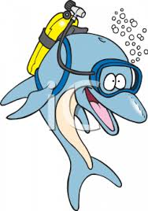

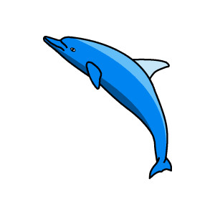


_{Learning Log}
In Numeracy the children have been reading scales. They began by weighing out ingredients to make our scones and then extended their learning by looking at a wider range of scales. They learned how to always check what the scale goes up to and to check what the intervals are before beginning. They finished the week by measuring temperature by reading thermometers and solving problems involving measures.

In Literacy this week the children have been learning about statements and commands. They have been practising using these types of sentences linked to their’ Handa’ work. They have planned their own journey stories based on Handa’s Surprise, which they will write next week. They have also been writing linked to our curriculum. We baked scones on Monday and they wrote a set of instructions. They learned how to develop their set of instructions to include a question and an exclamatory sentence.

_{Week beginning: 16.5.16}
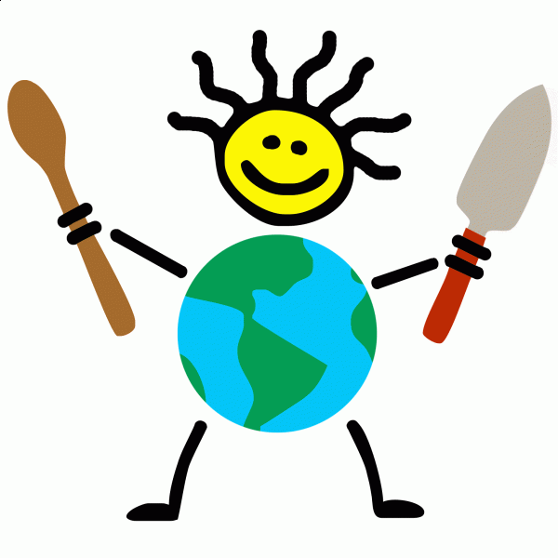

In Geography the learned about how different foods are grown in different countries and that this is sometimes because of the weather or the crops they have. We talked about how scones are a traditional food associated with the UK and then made some. Then they looked at how hotter countries grow tropical fruits. They tried papaya, pineapple, pomegranate, banana, grapes, mango and melon before designing and making their own fruit salads. They looked to see which countries these fruits were grown in and then found them using an atlas. I was very impressed with how adventurous they were with trying the different fruits!

Reminders – Please return your consent form for our trip to Vitacress Herb Nursery on Thursday.
WOW Work – Picnic plates are due in on Monday 23rd. There are suggestions on the website.
In Music the children practised playing musical conversations. They created their own conversations about food such as ‘What’s for dinner mum?’ ‘Eggs and bacon’ and then played them on the recorder using the A and C notes.

In Science we looked at the insides of bulbs and seeds using a magnifying glass. The children drew observational drawings and discussed the similarities and differences. Then they looked at different plants and sorted them based on whether or not they are plants we eat.

In SPAG the children have been learning about when to use full stops, question marks and exclamation marks.
In Multi-skills the children were practising their bowling and receiving skills before learning how to aim successfully.

