_{Hambledon Primary School}
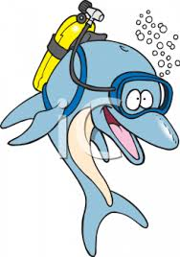



Spring Term 2 Dolphins Class Mrs Sansom / Mrs Blower

_{Learning Log}
On Thursday

Today we learnt about the British Value of Individual Liberty. We discussed what this means in our country and how we also have individual liberty in school. The children were surprised how many choices they are free to make for themselves!

We have learnt about the British artist Bridget Riley. We found out that her style of painting is called Op Art. We had a go at recreating her paintings using wavy and straight lines.
On Tuesday

It was a busy start back to half term! The children looked fabulous in their costumes and took great delight in having their photos taken and explaining who they were and why they were great.

They learnt about the British Value of Democracy and then discussed and drew what democracy meant to them. They named and located the four countries that make up Britain, learnt about their flags and their national flowers.

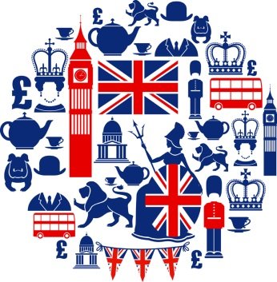
_{Week beginning: 22.2.16}


On Friday

We have had fun taking part in a dance workshop where we listened to British music and created movements to reflect British pastimes.

We have also been having our own Great British Bake Off! Thank you to all who sent in a delicious cake to be part of our competition. The winners will be announced at the end of the day
On Wednesday

On Wednesday the children learnt about the British Value of The Rule of Law. They talked about the laws they know about and who creates and enforces the law. They learnt about the judge and jury system and were able to explain why laws are important.

The children also learnt about two famous Brits: A.A. Milne and Alexander Graham Bell. They listened to a story by A.A. Milne before completing a book review. They learnt about Bell’s early life and the experiments he did that led to the invention of the telephone.

Music
In Music the children listened to Rule Britannia and discussed the music and the Royal Navy. They consolidated their writing of musical notation.


PE
We have been learning multi-skill games using cones and balls and having team races.

