_{Hambledon Primary School}
Spring Term 2 WB: 7/3/16 Dolphins Class Mrs Sansom / Mrs Blower
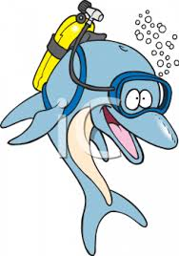

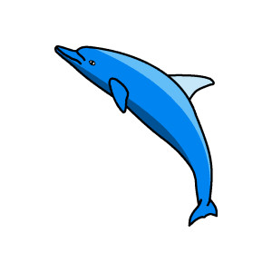


_{Learning Log}
In Literacy the children have been carrying on with the story ‘Lila and the Rain’. We have been looking at the sentence pattern used in the sentence ‘It was too hot to gather the fire wood, too hot to weed the vegetable garden and even too hot to milk the cow.’ The children have been practising writing their own ‘sentences of 3’ using commas for their lists. They have also been looking at how sentences of 3 can be used to describe a setting. At the end of the week, the children had a chance to put all of their recently learned skills into practise through retelling the story of Lila and the Secret of Rain’

In Numeracy the children have been learning how to divide. The ‘÷’ symbols was introduced and explained that it means ‘shared into groups of’. The children then practised reading number sentences and drawing out what it would look like using an array or by grouping. They then practised solving division number sentences before solving division word problems. At the end of the week the chidlren have been looking at how to decide if they have to multiply or divide to solve a word problem. We looked at the vocabulary for clues such as ‘altogether’ or ‘shared between’.

_{Week beginning: 29.2.16}

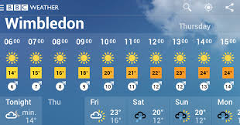
The children were composing dances to Vivaldi’s Four Seasons in dance. They began by listening to the music and thinking about what season it made them think of. Then they choreographed moves to represent Autumn. In multi-skills the children were practising their ball control using a hockey stick.
In Geography the children have been learning about the weather in the UK. They had to name and locate the four countries of the United Kingdom and their capital cities before using the BBC web page to find out what the weather was like in each of these places. They discussed similarities and differences before writing the weather reports for each city. They have also been learning about clouds. They learned what clouds were made from and looked at some of the different types of clouds. They looked at a map of the world showing annual rainfall and identified the continents that were the wettest. Finally, they learned about the Beaufort Scale used for measuring wind and made their own wind measuring devices.

In Art we have begun our unit on collages. The children looked at Eric Carle’s illustrations and thought about how he had made them. They watched a video of him preparing his pieces of paper that he uses for his artwork before preparing their own in a variety of colours. They used rollers, sponges, brushes and splatting.
Sport Relief-Friday 18th
Come dressed in your sports gear for a suggested £2 donation.
Sponsored hula hoop – How many can you complete in 15 minutes?

