_{Hambledon Primary School}
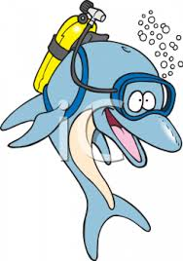
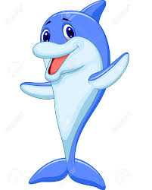
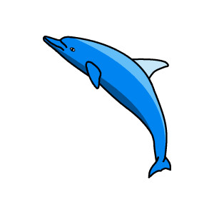
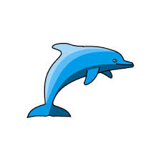
Spring Term 1 Dolphins Class Mrs Sansom / Mrs Hollingsworth

_{Learning Log}
Maths
In maths we have been telling the time this week. We are now confident at recognising quarter past, half past, quarter to and o’clock. We have also been solving problems using time as well.
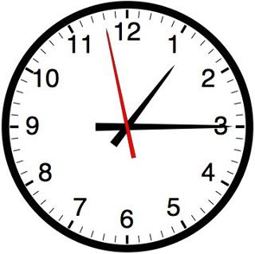
We have been practicing our 2 times table. To help us we have been finding the patterns in number grids and drawing pictures to show groups.

English
All our hard work over the last few weeks is now coming together as we have started to write our creation stories. Our steps to success are to use adjectives, conjunctions and time connectives. We are also thinking very carefully about our spellings and making sure our sentences make sense.

We have been writing explanations about how icebergs are formed. We have watched a video and read information to help us.
We have also been finishing our newspaper reports.
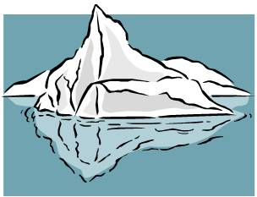
_{Week beginning: 1.2.16}
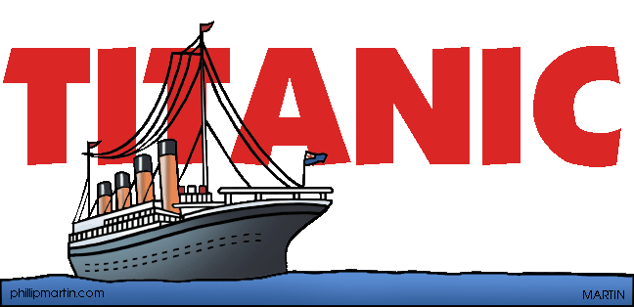

Class Assembly
On Friday 5th February at 9am we performed our Titanic assembly.
We were brilliant!
All our practicing of reading facts about the Titanic, acting and singing songs payed off. Thank you to all that came and supported us.

DT
Our designs for our pictures with moving parts are taking shape now. We have been busy cutting, colouring and sticking. We are paying a lot of attention to the look of our finished product. When we have finished making them we will be evaluating our pictures.


Phonics
This week we have continued to think about plurals. We have looked at plurals that are the same as their singular form, such as one sheep / two sheep and plurals that are completely different, for example child / children.
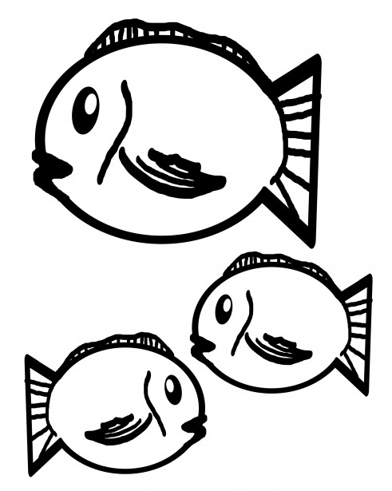
We have also been applying the spelling rules for ‘er’ and ‘est’ endings.
Music
We always have such a lovely time in music. This week we accompanied the song ‘Underneath the Sea’ using the xylophone. We also wrote our own music and our friends played it on tuned percussion.


PE
This week we played Slide Tag. We had to get our ball past a slider and in to a goal before we got tagged!

