_{Hambledon Primary School}
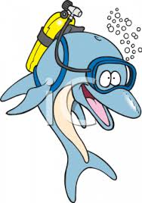
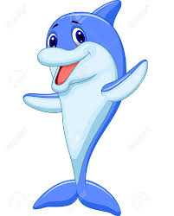
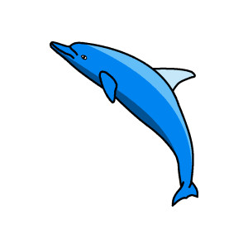
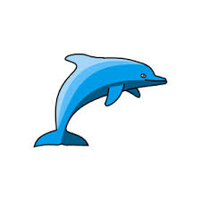
Spring Term 1 Dolphins Class Mrs Sansom / Mrs Hollingsworth

_{Learning Log}
English
This week we have been writing recounts for different passengers on board the Titanic. We planned our ideas in groups then wrote our own stories in our books.
We have also been writing Titanic acrostic poems. We have used the facts we know to make our poems more interesting for a reader.
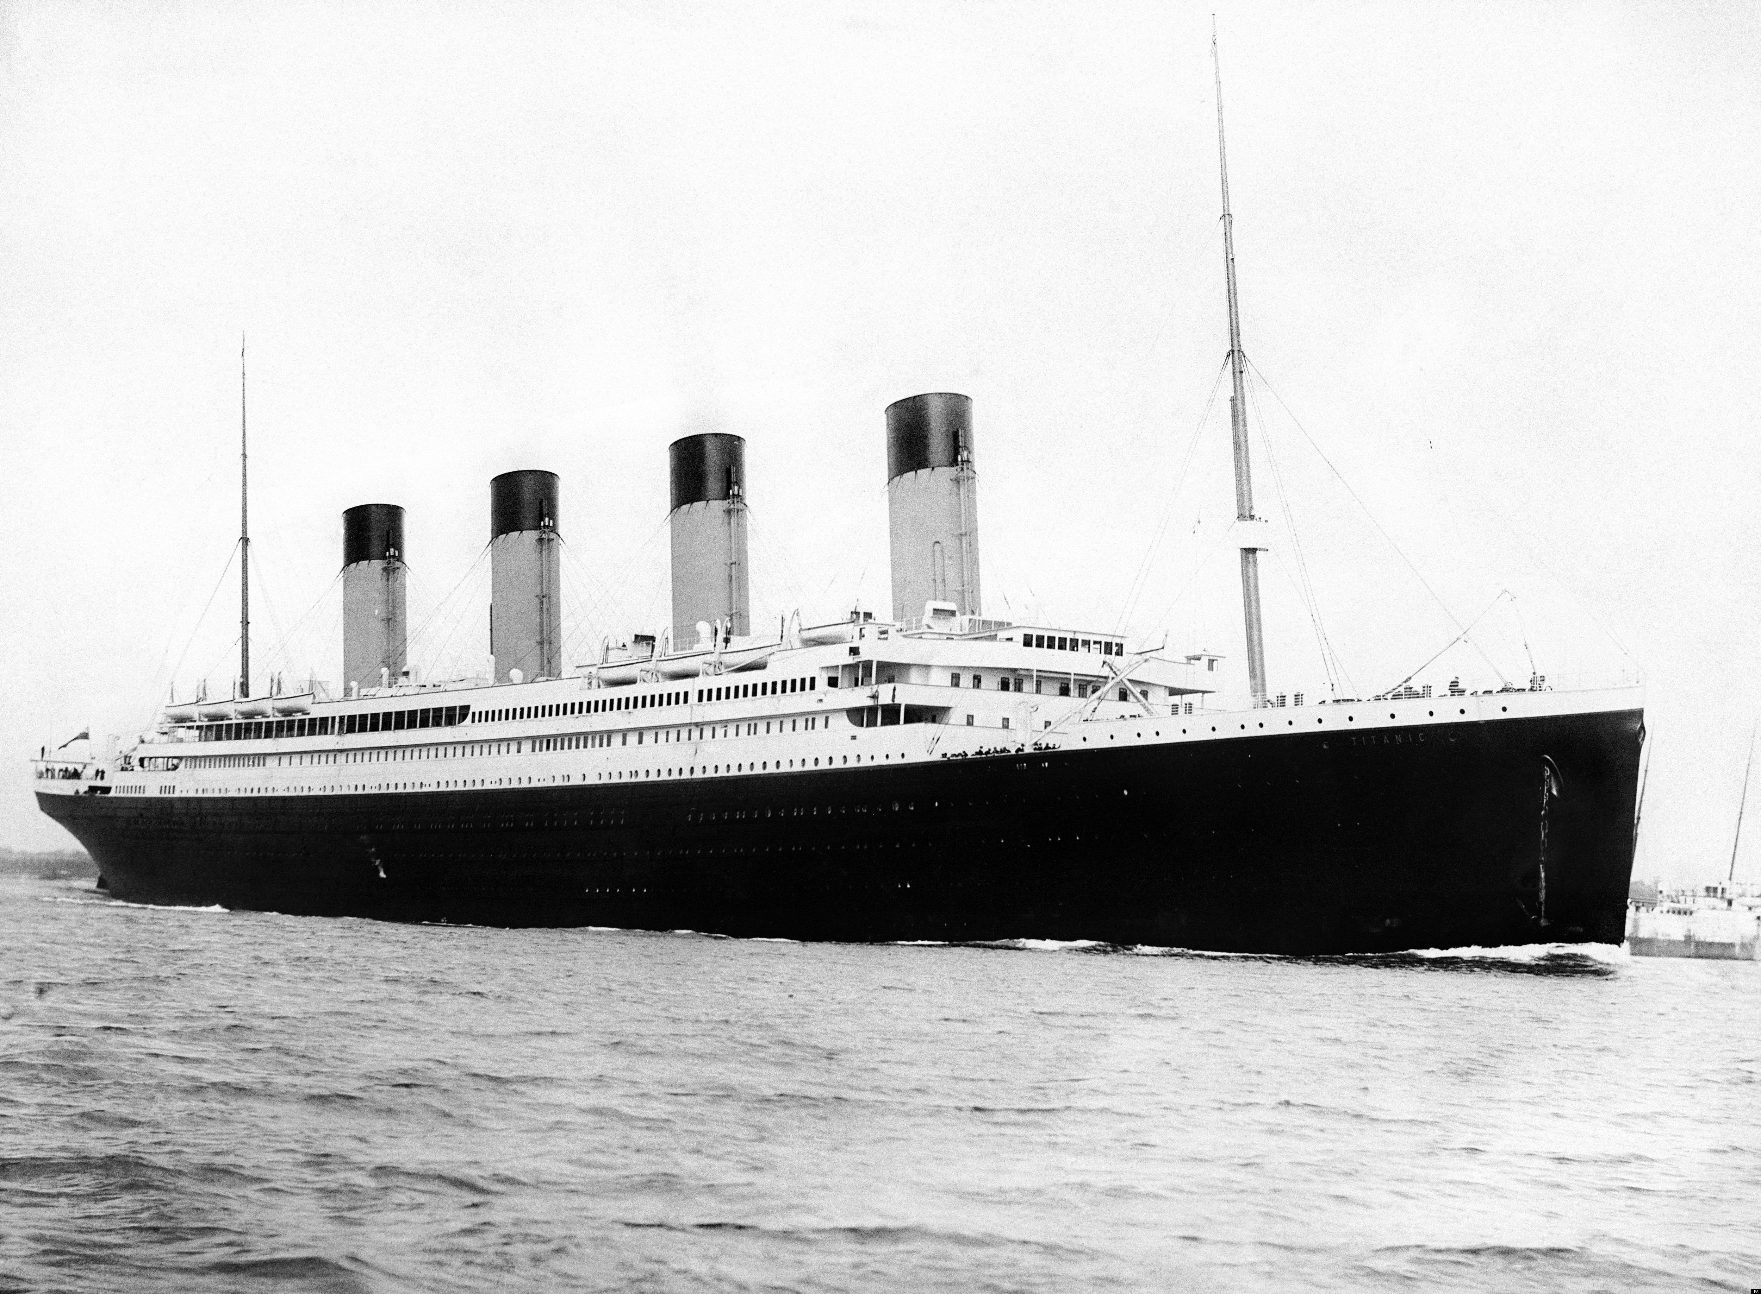
Maths
We linked our maths work to our science work at the start of this week. We drew and interpreted block graphs and pictograms about our favourite fruit juices. We tried four different fruit juices; cranberry, pineapple, orange and apple. Apple was the class favourite with cranberry coming a close second.
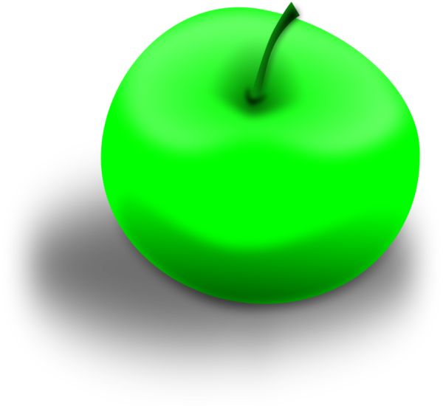
We have also been adding 2-digit numbers using a hundred square and drawing jumps on a landmarked number line. We have also learnt to add 2-digit numbers when crossing the tens barrier.

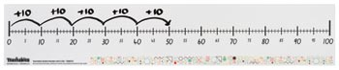
_{Week beginning: 8.2.16}
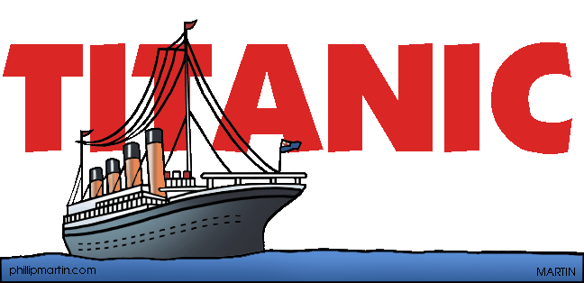

Music
In our music this week we sang a lovely song all about the Chinese New Year. We then used the pentatonic scale to play an accompaniment to the song.
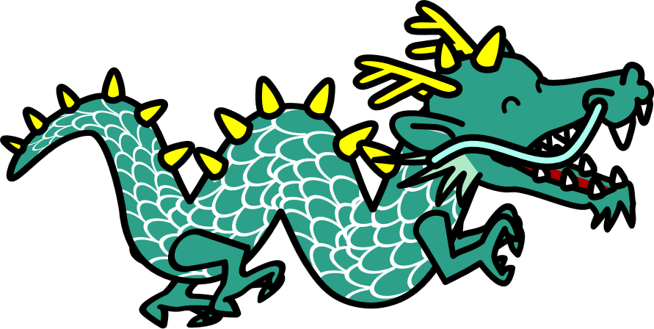

Science
One thing humans need to survive is a balanced diet. We discussed the different food groups needed for a balanced diet. We then drew our own ideas for a healthy lunchbox taking care to get a good balance of all the different types of food in it. Humans (and other animals) need exercise to be fit and healthy. We carried out some exercises in the classroom to find out how exercise affects our bodies. We then recorded our favourite ways of exercising at home and at school.


ICT
This week we have been learning about internet safety. We have watched a video and read information to help us understand how to stay safe.
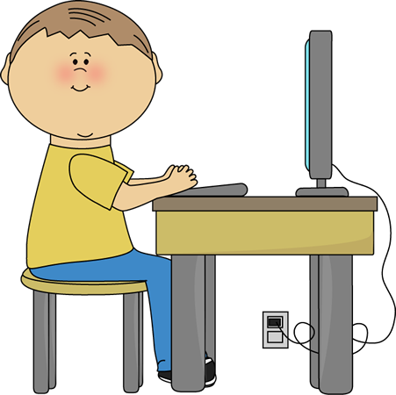
Phonics
We have begun to think more about adverbs. We have been spotting adverbs in text and using them to make our sentences more interesting. We have learnt the rules for adding ‘ly’ when a word ends in ‘y’ or ‘e’.
We have also been learning about verbal plurals. We have written sentences such as ‘I sit…’ ‘She sits …’

