_{Hambledon Primary School}
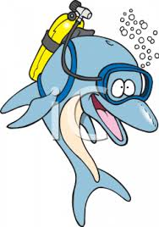
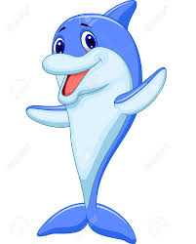
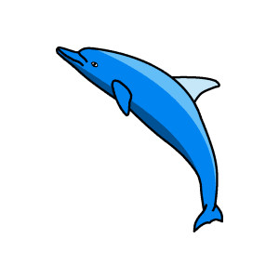
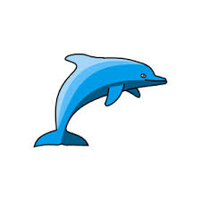
Spring Term 1 Dolphins Class Mrs Sansom / Mrs Hollingsworth

_{Learning Log}
English
Our English work has progressed quickly this week to us re-telling the story ‘How The World Was Made’ using our own story maps to help us. We are now writing the story out in our own words. The extra challenge for us was to use time connectives, adventurous adjectives and similes.

Maths
In Maths we started the week by revising what we already knew about subtraction. We then moved on to taking away 2-digit numbers by subtracting multiples of ten then the units using a 1-100 number square and landmarked lines. 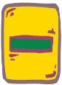

_{Week beginning: 18.1.16}
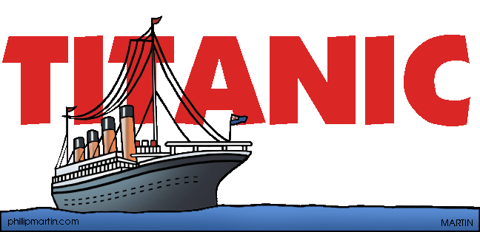

Design and Technology
We are still investigating how we can make pictures move in DT. In our lessons this week we investigated and made pictures from traditional tales move using levers and wheels. We also designed our own picture which used a lever to make part of it move.

Music
In music this week we explored and played high, low and middle notes. We put them together to make the tune ‘Hot Cross Buns’. We also talked about the timbres of wooden and metallic tuned instruments.

Science
In Science this week we have just about finished looking at different life cycles. We compared the life cycle of a butterfly, as reported in an information book, with the life cycle of the caterpillar in one of our favourite storybooks ‘The Very Hungry Caterpillar.
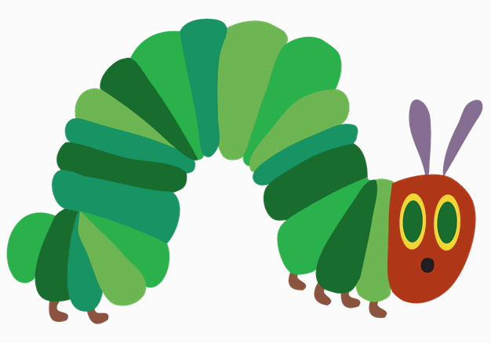
We then considered the life cycle of a chicken.
Next week we are going to start thinking about what do we need to do to sustain life. If any of the children have a pet and they would like to talk about how they look after it we would love to hear from them.

RE
In RE this week we have found out about how Hindus remember the story of Vishnu. They celebrate in a very different way by throwing coloured paint at each other! Some of us quite liked the idea of celebrating in this way.

Phonics
In phonics we have continued working on using apostrophes in words such as can’t and won’t.

SeaCity Museum
We have had a brilliant day learning about the people who were on board the Titanic. We had fun dressing up as different class passengers and looking at artefacts that have been found from the ship. Remember to look at the website to see our photos.
Please can you send in an email address that you are happy for your child to use.
Multiskills
We worked on our ball passing skills and throwing at targets.

