_{Hambledon Primary School}
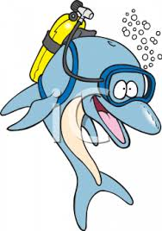

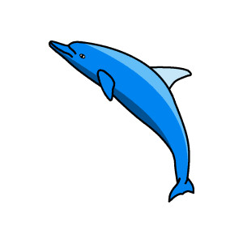

Spring Term 1 Dolphins Class Mrs Sansom / Mrs Hollingsworth

_{Learning Log}
Maths
In maths we are having a little break from subtracting and we have spent this week carrying out measuring activities, such as writing our names, using seconds and minutes. We have been using stop watches to do this.

English
In English this week we have planned our very own creation stories. We have even invented our own worlds as the setting for them. Next week we will start writing them. We also performed our story ‘How the World was Made’ to the rest of the school.

After a successful trip to the SeaCity museum we have used all our learning to do lots of writing. We have been writing newspaper reports about the Titanic and begun to make information books.
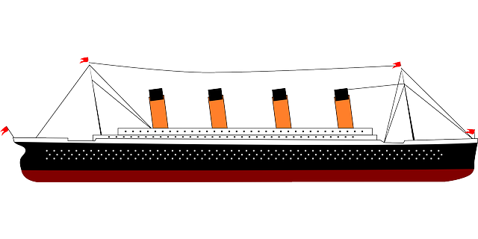
_{Week beginning: 25.1.16}
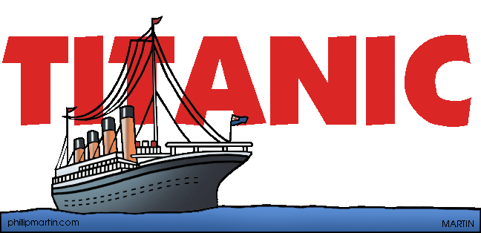

RE
In RE this week we have thought carefully about how we remember people and events. We are now coming up with our own ideas of how we can remember special events and special people.

Science
What do all animals need to survive? This is the question we thought about this week in science. Having discussed it we then designed a poster showing how to look after a pet ensuring they get the basics of water, food, air (and shelter). Some children also told the class how they care for their pets.
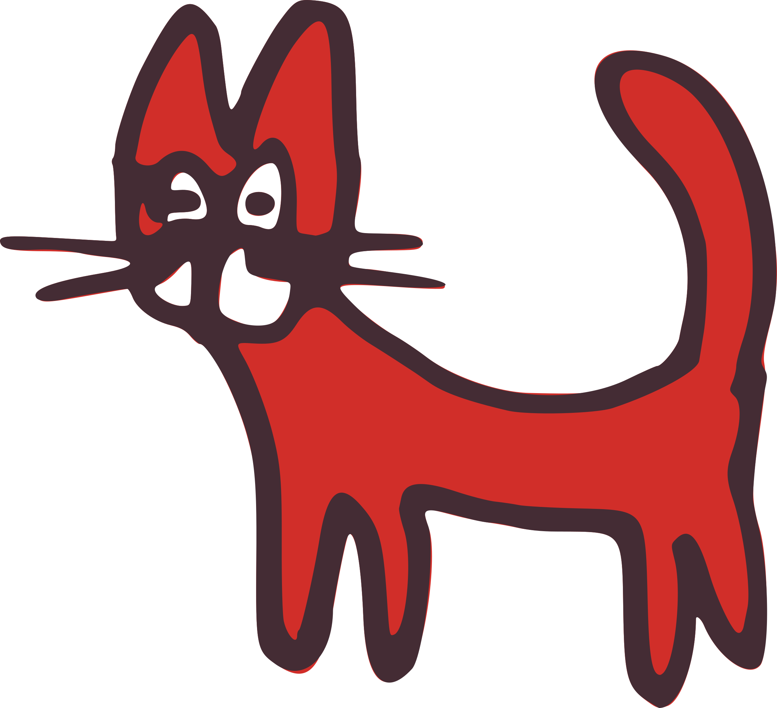

Music
In music this week we created our own high, low and middle pitched sequences in pairs. We also had great fun developing a body percussion sequence. We are very good at making noises with our bodies!
DT
We have now got on to the exciting part of designing our own individual moving pictures. First we decided which part of our own creation stories we would like to illustrate. Then we sketched and labelled our pictures showing the parts that will move and how they will move.

ICT
We drafted an email to our parents about our trip to the SeaCity museum. We also explored the SeaCity website.
Phonics
Our focus for our phonics work this week is changing a singular word into a plural by adding ‘s’ or ‘es’. Sometimes this is very simple and we just add ‘s’ but other times we need to look at whether it ends in a ‘ch’, ‘sh’, ‘ss’, ‘s’, ‘x’ or ‘z’ If it does we add ‘es’.
Class Assembly
We are getting excited about performing in our class assembly next week.
Friday 5th February at 9am
We have been practicing reading facts about the Titanic, acting and singing songs. We hope to see you there.
Costumes are optional!
Multiskills
We worked together to through bean bags at targets and dribble large balls towards a goal.
We had to help members of our team to get close to a goal.

