Hambledon Primary School
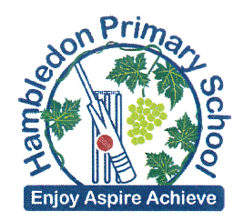
Homework

Week 1
Please return your homework to school by Tuesday 14th June 2016

Can you create a poster to persuade people to visit where you live?
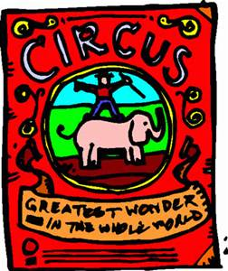
Think about:
- Making it bright, clear and interesting for a reader.
- Using headings and subheadings to organise.
- Using questions as headings.
- Writing an opening sentence to introduce the place.
- Using a range of punctuation.
- Using captions to give more information about illustrations.

Posters no bigger than A3 please.

