Hambledon Primary School

Homework

Week 3
Please return your homework to school by Tuesday 28th June 2016

In science we have been learning about microhabitats.
Which microhabitats are there in your garden?
Draw and label each microhabitat and the creatures that live there.
Answer these questions:
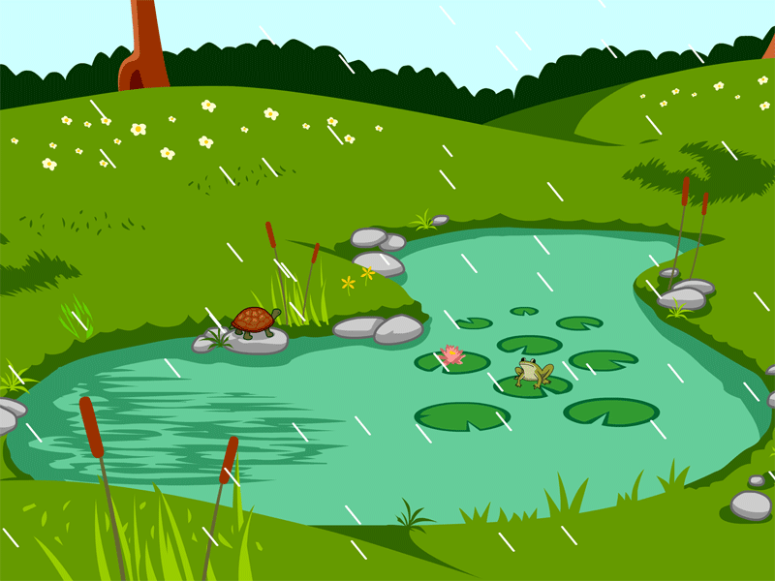
- Why do these animals like to live there?
- What other animals might live there?
- What could make this microhabitat change?

