Hambledon Primary School
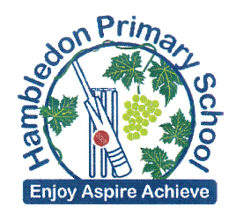
Homework

Week 5
Please return your homework to school by Tuesday 12th July 2016

It is nearly Rio Week!
Can you make a factual leaflet all about
the Rio Olympics?

Write information and draw pictures for 3 or more of these headings:

- Olympic facts
- Rio Olympic games
- Rio’s 28 Olympic sports
- Rio de Janeiro, Brazil
- Olympic athletes

Make it exciting and interesting for a reader!

